**IBM Data Science Capstone, Week 1 Final Project**

My name is Steven Harrison. As a computer network/systems administrator, software engineer, and solutions architect, I currently work for the Navajo Nation Head-Start school program. I provide leadership to a team of four computer professionals who provide strategic planning and managed IT services to the school administration, faculty, and regional offices of Head Start. Our IT mission is to provide a safe, reliable, stable technology environment so the school can accomplish its mission of providing quality educational services to Navajo children and their families.

For the final **IBM Data Science Capstone**, I would like to present the following scenario (business case) to complete the first week of the final project. To define the scenario, I would like to use elements of the *CRISP data mining method* and SDLC life cycle methodology (software development). The purpose of our first week assignment is communicating the importance and significance of ‘understanding and defining’ the goals and objectives of the data science project first in order to design and build a quality data science application for successful decision making and business planning purposes.

Week 1, Defining our Scenario and project goal and objectives, and using data to either solve our business problem or take advantage of a business opportunity.

1. **Business Scenario (Systems Planning, Phase I)**

As a computer systems technician, I’ve always wanted to open my own computer repair service business. It’s been a dream and passion to work beyond the constraints of a ordinary corporate IT job and work closer to the community and people. Where I am now, I’ve been saving money for a long time and wanted to invest in myself by opening my first shop. However, I wanted to relocate to an area of the country where the economy is robust and nurtures a strong possibility of success.

The new business location should be in an area where being a mobile service provider would be a niche into the new market. The area would also have to have a strong stable economy with a large enough population that provides the **service demand** necessary to bring about short-term success. The target customers and the service we deliver should provide a stable income stream as the business builds its foundation and reputation in the community. The area should also have a strong technology base and have income levels where computer support can be provided at a reasonable price and cost.

I’ve decided to relocate and set-up my new business in Colorado Springs, CO. As a sole proprietor and sole investor, I would like to provide computer repair services to an area that is located near the Garden of the Gods / North Academy and Central CS where there is economic growth and stability. The area presents sales opportunities in a large travel corridor (I-25, hotels, business conference travelers), mobile users, and home computer user markets. My business tradename is Pike’s Computer Repair and Service.

The following map illustrates the market I would like to relocate and set up Pike’s.

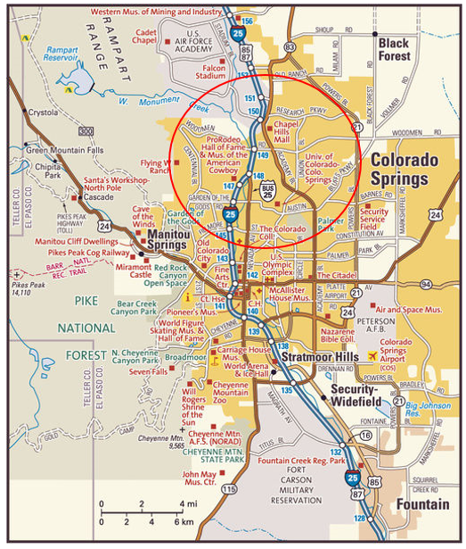

1. **Project Goal and objectives (business understanding)**

In order to strengthen our business plan and the decision to relocate to Colorado Springs, we need to do some research into the Colorado Springs area and the market location where we want to do business. I need to develop a data science application that analyzes three (3) important characteristics of the market of where we’re going to set up shop. These characteristics are:

1. **Income Levels** in the desired target market.
2. **Competition** from other computer service businesses.
3. **Accessibility to mobile customers** (hotels business travelers, conferences, trainings, etc.).

The data science application should present location data that identifies households/ neighborhoods and hotels located near interstate highways who serve business travelers who require specialized mobile IT services. We also need to identify and locate our competition in the target market that includes their proximity to our location and what services they provide. We can also use our competition to define a baseline price strategy based on local income levels and demand.

1. **Data (understanding and modeling)**

I would like to use the Foursquare location data to find all computer service businesses in the Colorado Springs area. I would then narrow that data down to the area I would like to relocate and do business. I would like to use local demographic data based on zip code information to show the median incomes in the area. This income data can be displayed using Folium graphics or in a Pandas data frame using bar charts. I would also like to know the median ages of our target market, education levels, etc.

I would also like to use Foursquare location data to find all the hotels in the area. We are interested in the location of the hotels nearest the interstate that provide services for corporate travelers, trainings or events. The following example sample data is available thru the Colorado Springs Chamber of Commerce:

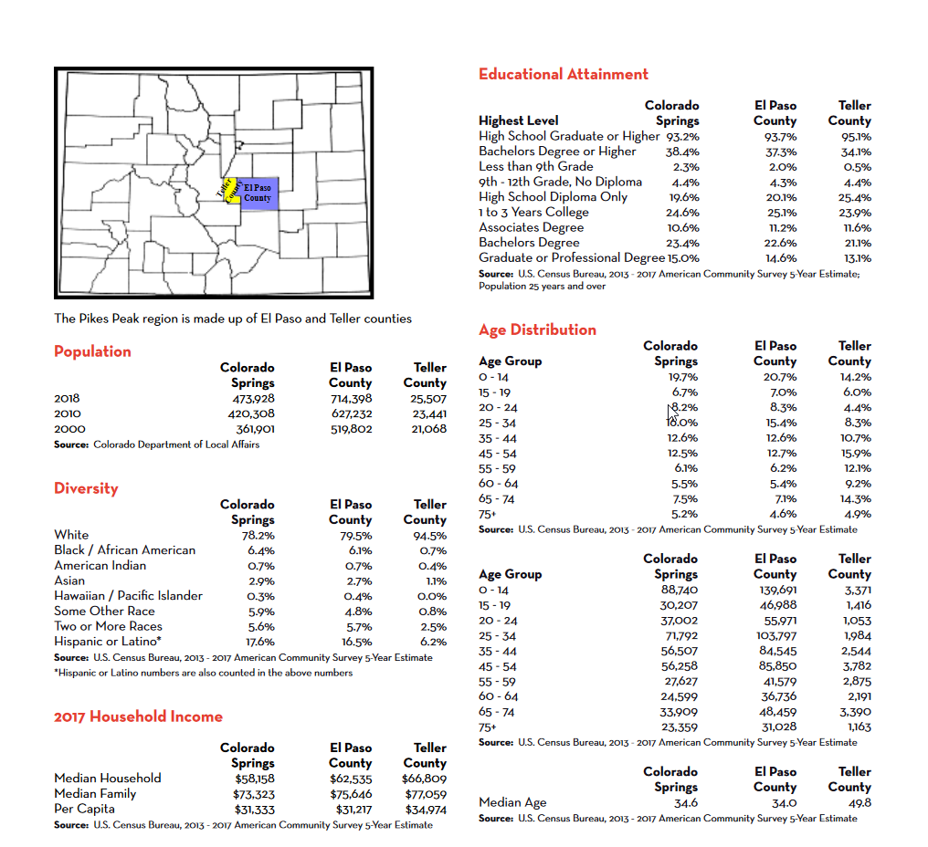

1. **Using our analysis to make an informed decision about our location and business markets. (Evaluation)**

I will use our data analysis to either support our business venture in Colorado Springs or make the decision to either find another location or cancel the business plan all together. If there is a GO decision based on the data, I would like to use the Foursquare location data to find a place to call home. Again, our home would have to fall within our budget and have reasonable access to our target markets. We would need access to a local Super Walmart, government services, shippers, computer parts and supplies, etc.